**Database for Hospital Management**

1. **Description of the project**

This project analyzes employee data to manage staffing costs, examines departmental budgets to enhance resource allocation, and evaluates patient care costs to streamline services. Additionally, it tracks medical supply usage to improve inventory efficiency. By analyzing data across these areas, the project identifies cost drivers, reduces waste, and improves profitability. Using past data for financial forecasting, the project provides tools for better planning and smarter decision-making, supporting both efficiency and high-quality patient care.

1. 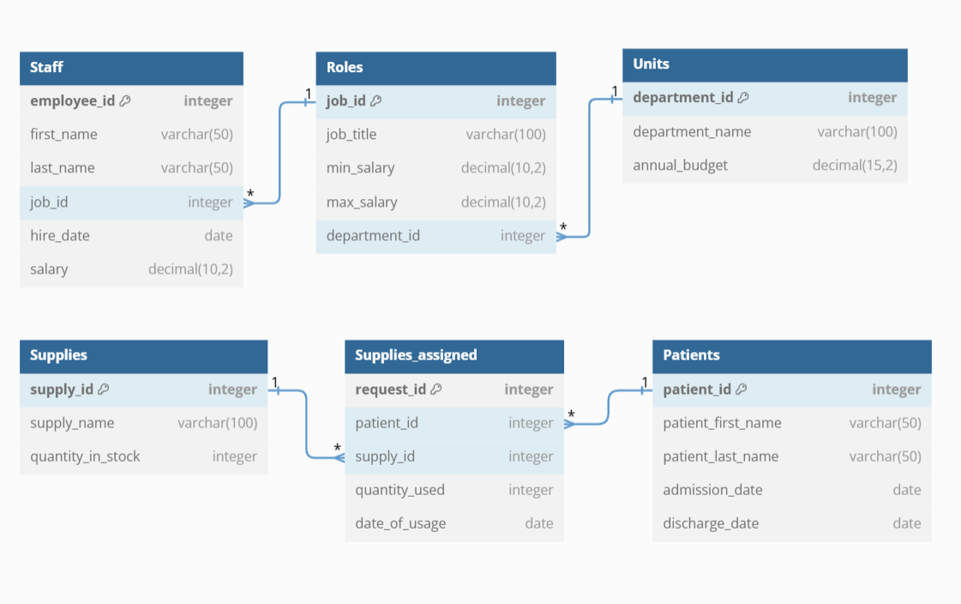**Database schema**
2. **Constructing the database**

--creating the tables

CREATE TABLE Staff (

employee_id INT PRIMARY KEY,

first_name VARCHAR(50),

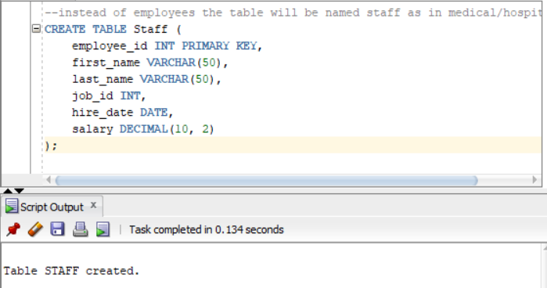 last_name VARCHAR(50),

job_id INT,

hire_date DATE,

salary DECIMAL(10, 2)

);

CREATE TABLE roles (

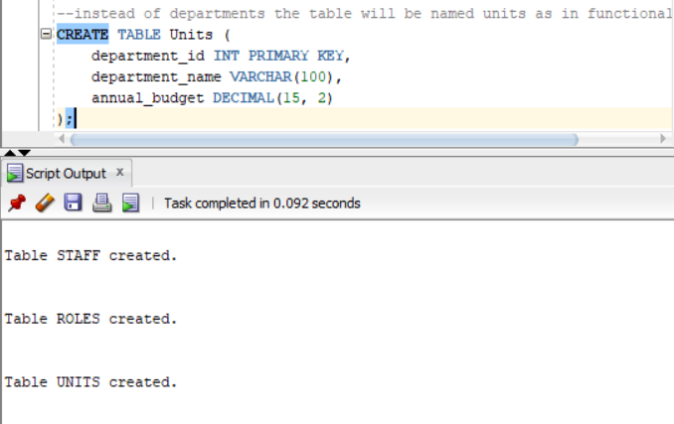 job_id INT PRIMARY KEY,

job_title VARCHAR(100),

min_salary DECIMAL(10, 2),

max_salary DECIMAL(10, 2),

department_id INT

);



CREATE TABLE units (

department_id INT PRIMARY KEY,

department_name VARCHAR(100),

annual_budget DECIMAL(15, 2)

);

CREATE TABLE Patients (

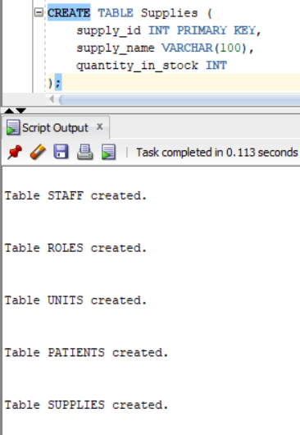 patient_id INT PRIMARY KEY,

patient_first_name VARCHAR(50),

patient_last_name VARCHAR(50),

admission_date DATE,

discharge_date DATE

);

CREATE TABLE Supplies(

supply_id INT PRIMARY KEY,

supply_name VARCHAR(100),

quantity_in_stock INT

);

CREATE TABLE Supplies_assigned (

request_id INT,

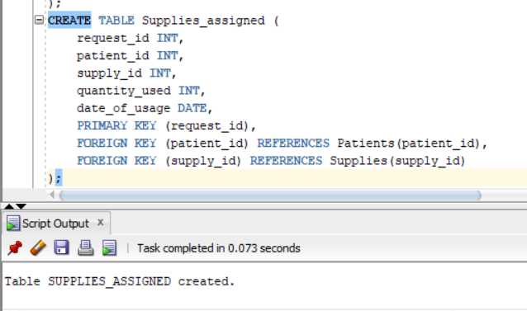 patient_id INT,

supply_id INT,

quantity_used INT,

date_of_usage DATE,

PRIMARY KEY (request_id),

FOREIGN KEY (patient_id) REFERENCES Patients(patient_id),

FOREIGN KEY (supply_id) REFERENCES Supplies(supply_id)

);

--

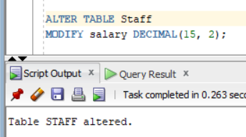ALTER TABLE Staff

MODIFY salary DECIMAL(15, 2);

--

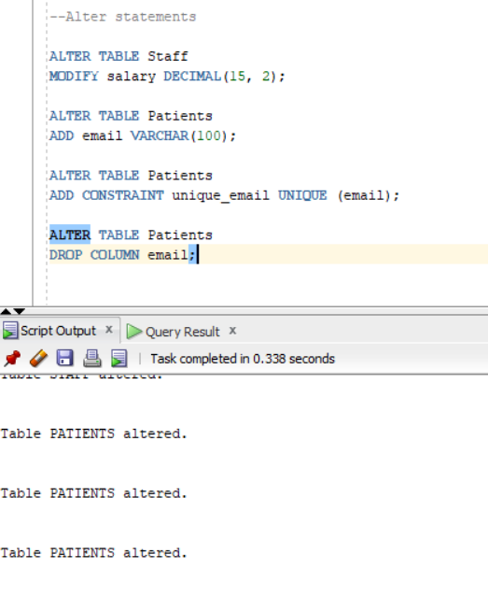

ALTER TABLE Patients

ADD email VARCHAR(100);

--

ALTER TABLE Patients

ADD CONSTRAINT unique_email UNIQUE (email);

--

ALTER TABLE Patients

DROP COLUMN email;

--

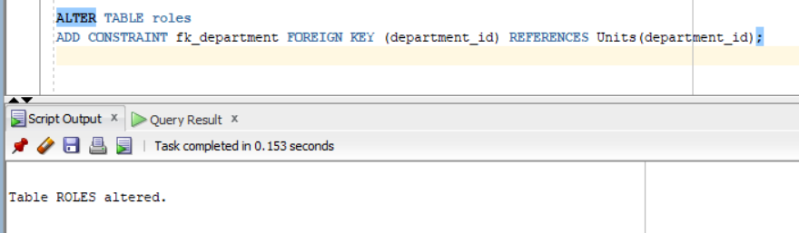ALTER TABLE roles

ADD CONSTRAINT fk_department

FOREIGN KEY (department_id)

REFERENCES Units(department_id);

--

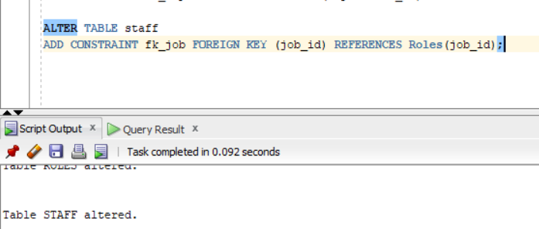ALTER TABLE staff

ADD CONSTRAINT fk_job

FOREIGN KEY (job_id)

REFERENCES Roles(job_id);

1. **DML statements: INSERT, UPDATE, DELETE, and MERGE**

--Inserting values into Staff table

INSERT INTO staff(employee_id, first_name, last_name, job_id, hire_date, salary)

VALUES (1, 'John', 'Doe', 2, TO_DATE ('2022-01-15', 'YYYY-MM-DD'), 35000.00);

INSERT INTO staff (employee_id, first_name, last_name, job_id, hire_date, salary)

VALUES (2, 'Mark', 'Smith', 3, TO_DATE ('2022-05-23', 'YYYY-MM-DD'), 63000);

INSERT INTO staff (employee_id, first_name, last_name, job_id, hire_date, salary)

VALUES (3, 'Carry', 'Donovan', 1, TO_DATE ('2023-10-06', 'YYYY-MM-DD'), 77000);

INSERT INTO staff (employee_id, first_name, last_name, job_id, hire_date, salary)

VALUES (4, 'Lucas', 'Taylor', 4, TO_DATE ('2021-02-11', 'YYYY-MM-DD'), 50000);

INSERT INTO staff (employee_id, first_name, last_name, job_id, hire_date, salary)

VALUES (5, 'Chloe', 'Perez', 2, TO_DATE ('2022-03-20', 'YYYY-MM-DD'), 45000);

INSERT INTO staff (employee_id, first_name, last_name, job_id, hire_date, salary)

VALUES (6, 'Noah', 'Adams', 5, TO_DATE ('2020-09-01', 'YYYY-MM-DD'), 49000);

INSERT INTO staff (employee_id, first_name, last_name, job_id, hire_date, salary)

VALUES (7, 'Ava', 'Nelson', 3, TO_DATE ('2022-08-15', 'YYYY-MM-DD'),60000);

INSERT INTO staff (employee_id, first_name, last_name, job_id, hire_date, salary)

VALUES (8, 'Elijah', 'Carter', 6, TO_DATE ('2021-11-22', 'YYYY-MM-DD'), 47000);

INSERT INTO staff (employee_id, first_name, last_name, job_id, hire_date, salary)

VALUES (9, 'Grace', 'Mitchell', 1, TO_DATE ('2023-04-30', 'YYYY-MM-DD'), 87000);

INSERT INTO staff (employee_id, first_name, last_name, job_id, hire_date, salary)

VALUES (10, 'Logan', 'Gonzalez', 4, TO_DATE ('2020-07-13', 'YYYY-MM-DD'), 54000);

INSERT INTO staff (employee_id, first_name, last_name, job_id, hire_date, salary)

VALUES (11, 'Zoe', 'Rodriguez', 2, TO_DATE ('2021-10-10', 'YYYY-MM-DD'), 44000);

INSERT INTO staff (employee_id, first_name, last_name, job_id, hire_date, salary)

VALUES (12, 'Daniel', 'Hall', 6, TO_DATE ('2023-06-07', 'YYYY-MM-DD'), 37000);

INSERT INTO staff (employee_id, first_name, last_name, job_id, hire_date, salary)

VALUES (13, 'Ella', 'Scott', 3, TO_DATE ('2022-04-19', 'YYYY-MM-DD'), 60000);

INSERT INTO staff (employee_id, first_name, last_name, job_id, hire_date, salary)

VALUES (14, 'Jackson', 'Young', 1, TO_DATE ('2023-09-05', 'YYYY-MM-DD'), 85000);

SELECT * FROM staff;

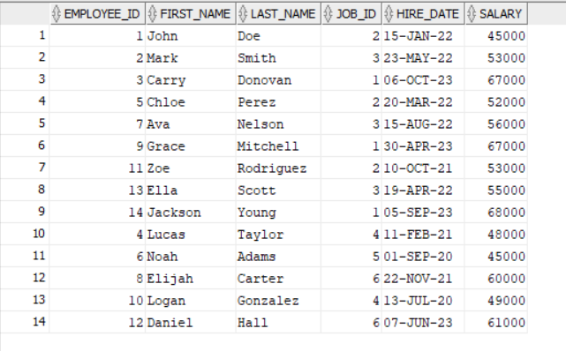

--Inserting values into Roles table

INSERT INTO roles (job_id, job_title, min_salary, max_salary, department_id)

VALUES (2, 'Nurse', 25000, 50000,2);

INSERT INTO roles (job_id, job_title, min_salary, max_salary, department_id)

VALUES (3, 'Doctor', 45000, 65000,3);

INSERT INTO roles (job_id, job_title, min_salary, max_salary, department_id)

VALUES (1, 'Surgeon', 50000, 90000,1);

INSERT INTO roles (job_id, job_title, min_salary, max_salary, department_id)

VALUES (4, 'Pharmacist', 40000, 70000, 7);

INSERT INTO roles (job_id, job_title, min_salary, max_salary, department_id)

VALUES (5, 'Radiologist', 45000, 75000, 1);

INSERT INTO roles (job_id, job_title, min_salary, max_salary, department_id)

VALUES (6, 'Physiotherapist', 30000, 60000, 2);

INSERT INTO roles (job_id, job_title, min_salary, max_salary, department_id)

VALUES (7, 'Anesthesiologist', 60000, 95000, 5);

SELECT * FROM roles;

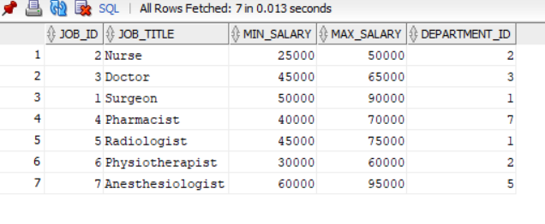

--Inserting values into Units table

INSERT INTO units (department_id, department_name, annual_budget)

VALUES (1, 'Emergency', 2200000.00);

INSERT INTO units (department_id, department_name, annual_budget)

VALUES (2, 'Orthopedics', 2000000);

INSERT INTO units (department_id, department_name, annual_budget)

VALUES (3, 'Pediatrics', 2500000);

INSERT INTO units (department_id, department_name, annual_budget)

VALUES (4, 'Radiology', 1800000);

INSERT INTO units (department_id, department_name, annual_budget)

VALUES (5, 'Cardiology', 3000000);

INSERT INTO units (department_id, department_name, annual_budget)

VALUES (6, 'Neurology', 2700000);

INSERT INTO units (department_id, department_name, annual_budget)

VALUES (7, 'Oncology', 3200000);

SELECT * FROM units;

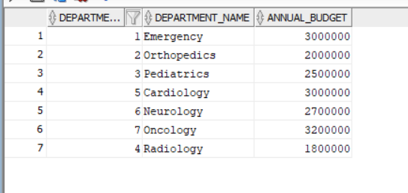

--Inserting values into Patients table

INSERT INTO patients (patient_id, patient_first_name, patient_last_name, admission_date, discharge_date)

VALUES (1, 'Alice', 'Smith', TO_DATE ('2023-03-11', 'YYYY-MM-DD'), TO_DATE ('2023-03-15', 'YYYY-MM-DD'));

INSERT INTO patients (patient_id, patient_first_name, patient_last_name, admission_date, discharge_date)

VALUES (2, 'Malcom', 'Davis', TO_DATE ('2024-01-16', 'YYYY-MM-DD'), TO_DATE ('2024-02-01', 'YYYY-MM-DD'));

INSERT INTO patients (patient_id, patient_first_name, patient_last_name, admission_date, discharge_date)

VALUES (3, 'Ioana Alexandra', 'Ilinca', TO_DATE ('2025-01-16', 'YYYY-MM-DD'), TO_DATE ('2025-01-17', 'YYYY-MM-DD'));

INSERT INTO patients (patient_id, patient_first_name, patient_last_name, admission_date, discharge_date)

VALUES (4, 'John', 'Raye', TO_DATE ('2022-12-20', 'YYYY-MM-DD'), TO_DATE ('2022-12-28', 'YYYY-MM-DD'));

INSERT INTO patients (patient_id, patient_first_name, patient_last_name, admission_date, discharge_date)

VALUES (5, 'Emma', 'Johnson', TO_DATE ('2023-04-01', 'YYYY-MM-DD'), TO_DATE ('2023-04-10', 'YYYY-MM-DD'));

INSERT INTO patients (patient_id, patient_first_name, patient_last_name, admission_date, discharge_date)

VALUES (6, 'Liam', 'Brown', TO_DATE ('2023-06-15', 'YYYY-MM-DD'), TO_DATE ('2023-06-20', 'YYYY-MM-DD'));

INSERT INTO patients (patient_id, patient_first_name, patient_last_name, admission_date, discharge_date)

VALUES (7, 'Olivia', 'Garcia', TO_DATE ('2023-07-10', 'YYYY-MM-DD'), TO_DATE ('2023-07-18', 'YYYY-MM-DD'));

INSERT INTO patients (patient_id, patient_first_name, patient_last_name, admission_date, discharge_date)

VALUES (8, 'Ethan', 'Martinez', TO_DATE ('2023-08-22', 'YYYY-MM-DD'), TO_DATE ('2023-08-25', 'YYYY-MM-DD'));

INSERT INTO patients (patient_id, patient_first_name, patient_last_name, admission_date, discharge_date)

VALUES (9, 'Sophia', 'Lee', TO_DATE ('2023-09-12', 'YYYY-MM-DD'), TO_DATE ('2023-09-18', 'YYYY-MM-DD'));

INSERT INTO patients (patient_id, patient_first_name, patient_last_name, admission_date, discharge_date)

VALUES (10, 'James', 'Hernandez', TO_DATE ('2023-10-03', 'YYYY-MM-DD'), TO_DATE ('2023-10-11', 'YYYY-MM-DD'));

INSERT INTO patients (patient_id, patient_first_name, patient_last_name, admission_date, discharge_date)

VALUES (11, 'Isabella', 'Clark', TO_DATE ('2023-11-15', 'YYYY-MM-DD'), TO_DATE ('2023-11-22', 'YYYY-MM-DD'));

INSERT INTO patients (patient_id, patient_first_name, patient_last_name, admission_date, discharge_date)

VALUES (12, 'Michael', 'Lopez', TO_DATE ('2024-01-10', 'YYYY-MM-DD'), TO_DATE ('2024-01-20', 'YYYY-MM-DD'));

INSERT INTO patients (patient_id, patient_first_name, patient_last_name, admission_date, discharge_date)

VALUES (13, 'Mia', 'White', TO_DATE ('2024-02-25', 'YYYY-MM-DD'), TO_DATE ('2024-03-05', 'YYYY-MM-DD'));

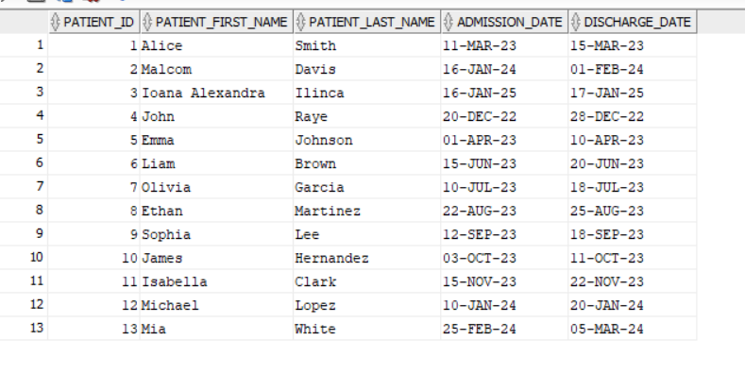SELECT * FROM patients;

--Inserting values into Supplies table

INSERT INTO supplies (supply_id, supply_name, quantity_in_stock)

VALUES (1, 'Syringe', 500);

INSERT INTO supplies (supply_id, supply_name, quantity_in_stock)

VALUES (2, 'IV', 630);

INSERT INTO supplies (supply_id, supply_name, quantity_in_stock)

VALUES (3, 'Scalpels', 350);

INSERT INTO supplies (supply_id, supply_name, quantity_in_stock)

VALUES (4, 'Bandages', 1200);

INSERT INTO supplies (supply_id, supply_name, quantity_in_stock)

VALUES (5, 'Gloves', 2000);

INSERT INTO supplies (supply_id, supply_name, quantity_in_stock)

VALUES (6, 'Face Masks', 1500);

INSERT INTO supplies (supply_id, supply_name, quantity_in_stock)

VALUES (7, 'Thermometers', 300);

INSERT INTO supplies (supply_id, supply_name, quantity_in_stock)

VALUES (8, 'Stethoscopes', 100);

SELECT * FROM supplies;

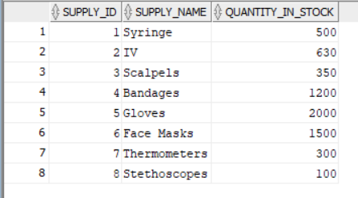

--Insert values into Supplies_assigned values

INSERT INTO supplies_assigned (request_id, patient_id, supply_id, quantity_used, date_of_usage)

VALUES (171,1, 2, 1, TO_DATE('2023-11-12', 'YYYY-MM-DD'));

INSERT INTO supplies_assigned (request_id, patient_id, supply_id, quantity_used, date_of_usage)

VALUES (1432,2, 3, 1, TO_DATE ('2024-01-16', 'YYYY-MM-DD'));

INSERT INTO supplies_assigned (request_id, patient_id, supply_id, quantity_used, date_of_usage)

VALUES (1123, 3, 1, 2, TO_DATE('2025-01-16', 'YYYY-MM-DD'));

INSERT INTO supplies_assigned (request_id, patient_id, supply_id, quantity_used, date_of_usage)

VALUES (1204, 1, 4, 3, TO_DATE('2023-03-11', 'YYYY-MM-DD'));

INSERT INTO supplies_assigned (request_id, patient_id, supply_id, quantity_used, date_of_usage)

VALUES (1547, 2, 5, 2, TO_DATE('2024-01-20', 'YYYY-MM-DD'));

INSERT INTO supplies_assigned (request_id, patient_id, supply_id, quantity_used, date_of_usage)

VALUES (1629, 3, 6, 1, TO_DATE('2025-01-17', 'YYYY-MM-DD'));

INSERT INTO supplies_assigned (request_id, patient_id, supply_id, quantity_used, date_of_usage)

VALUES (1780, 1, 3, 1, TO_DATE('2023-03-13', 'YYYY-MM-DD'));

INSERT INTO supplies_assigned (request_id, patient_id, supply_id, quantity_used, date_of_usage)

VALUES (1902, 2, 8, 1, TO_DATE('2024-02-01', 'YYYY-MM-DD'));

INSERT INTO supplies_assigned (request_id, patient_id, supply_id, quantity_used, date_of_usage)

VALUES (2015, 3, 7, 4, TO_DATE('2025-01-16', 'YYYY-MM-DD'));

INSERT INTO supplies_assigned (request_id, patient_id, supply_id, quantity_used, date_of_usage)

VALUES (2156, 1, 2, 2, TO_DATE('2023-03-14', 'YYYY-MM-DD'));

SELECT * FROM supplies_assigned;

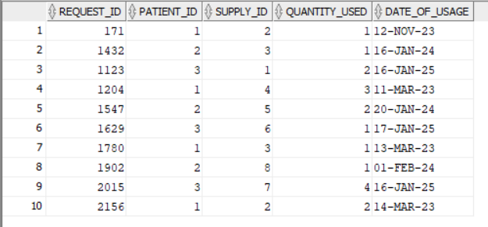

--

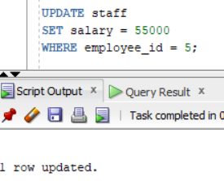UPDATE staff

SET salary = 55000

WHERE employee_id = 5;

--

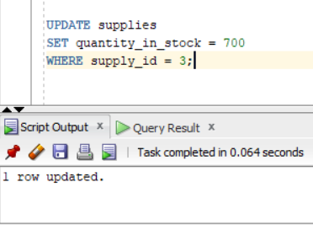UPDATE supplies

SET quantity_in_stock = 700

WHERE supply_id = 3;

--

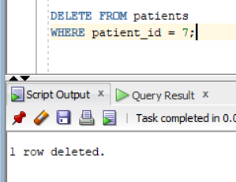DELETE FROM patients

WHERE patient_id = 7;

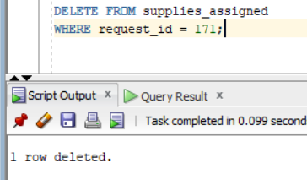--

DELETE FROM supplies_assigned

WHERE request_id = 171;

--Insert a new employee into the staff table with job_id = 7 if no such job already exists in the staff table, using max_salary from the roles table

MERGE INTO staff target

USING (

SELECT job_id, max_salary

 FROM roles

WHERE job_id = 7

) source

ON (target.job_id = source.job_id)

WHEN NOT MATCHED THEN

INSERT (employee_id, first_name, last_name, job_id, hire_date, salary)

VALUES (15, 'Alice', 'Johnson', source.job_id, DATE '2024-02-20', source.max_salary);

**5. Diverse and relevant SELECT statements for the project theme**

**-- 1.Employees with salaries greater than 50,000**

SELECT * FROM staff

WHERE salary > 50000;

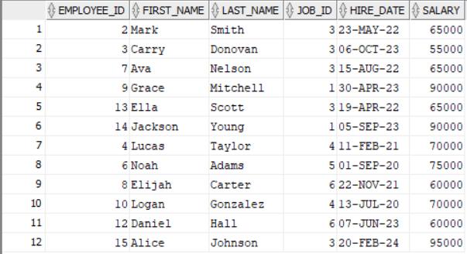

**--2.Patients whose admission date is before 2024**

SELECT * FROM patients

WHERE admission_date < TO_DATE('2024-01-01', 'YYYY-MM-DD');

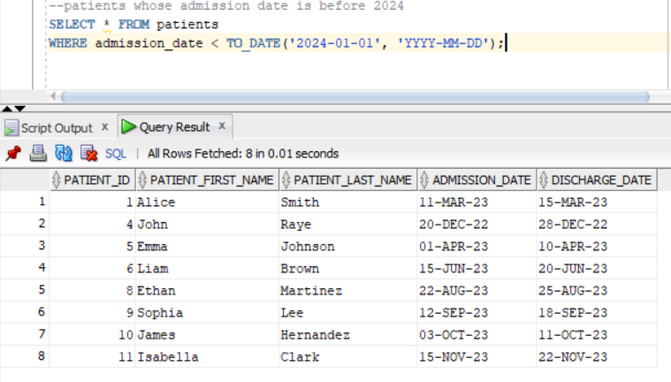

**--3.Patients with missing discharge dates**

SELECT * FROM patients

WHERE discharge_date IS NULL;

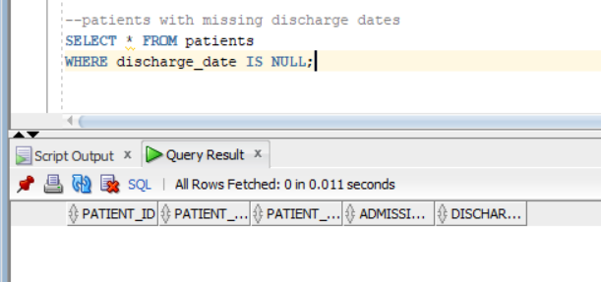

**--4.Patients whose last name starts with 'S'**

SELECT * FROM patients

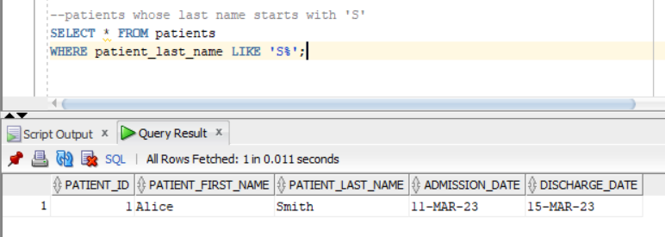WHERE patient_last_name LIKE 'S%';

**--5.Supplies that are either 'Syringe' or 'Bandages'**

SELECT * FROM supplies

WHERE supply_name IN ('Syringe', 'Bandages');

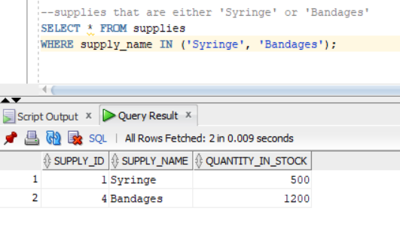

**--6.Employees who were hired between 2022 and 2023**

SELECT * FROM staff

WHERE hire_date BETWEEN TO_DATE('2022-01-01', 'YYYY-MM-DD')

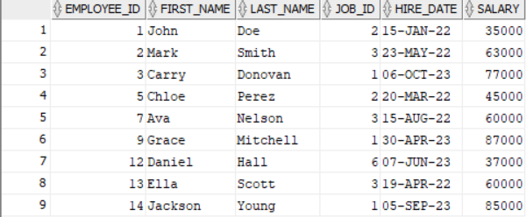AND TO_DATE('2023-12-31', 'YYYY-MM-DD');

**-- 7.Employees with salaries greater than any of the given values**

SELECT * FROM staff

WHERE salary > ANY (SELECT salary FROM staff WHERE job_id = 3);

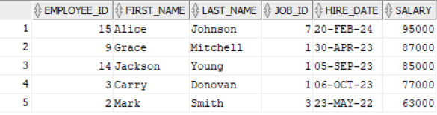

**-- 8.Patients with admission dates earlier than all patients with a specific id**

SELECT * FROM patients

WHERE admission_date < ALL (SELECT admission_date FROM patients WHERE patient_id = 8);

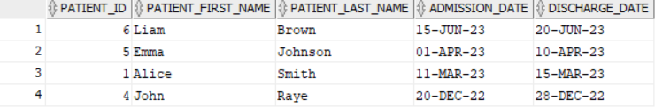

**--9.Calculate total salaries for each job title by summing salaries and grouping by job_title**

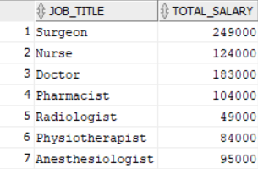SELECT r.job_title,

SUM(s.salary) AS total_salary

FROM roles r

JOIN staff s ON r.job_id = s.job_id

GROUP BY r.job_title;

**--10.Employees and their roles**

SELECT s.first_name, s.last_name, r.job_title

FROM staff s

INNER JOIN roles r ON s.job_id = r.job_id;

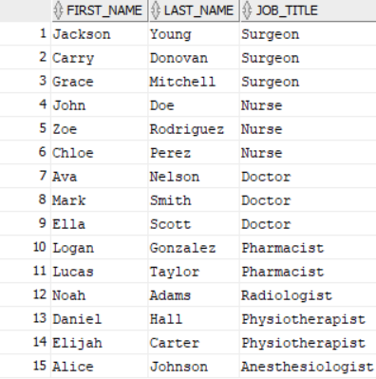

**--11.All patients and their supply usage, including patients who did not use supplies**

SELECT p.patient_first_name, p.patient_last_name, sa.supply_id, sa.quantity_used

FROM patients p

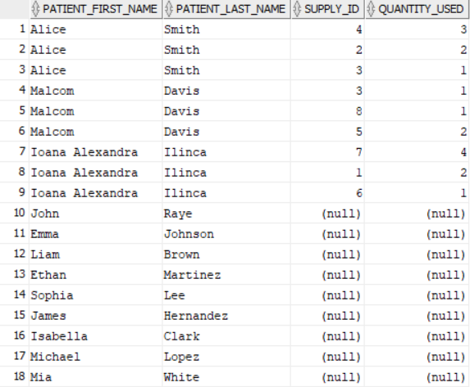LEFT JOIN supplies_assigned sa ON p.patient_id = sa.patient_id;

**--12.Total quantity of syringes used**

SELECT SUM(quantity_used) AS total_syringes_used

FROM supplies_assigned

WHERE supply_id = 1;

**--13.Number of employees in each role**

SELECT job_id, COUNT(*) AS employee_count

FROM staff

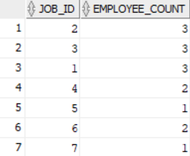GROUP BY job_id;

**--14.Average salary per role**

SELECT job_id, AVG(salary) AS avg_salary

FROM staff

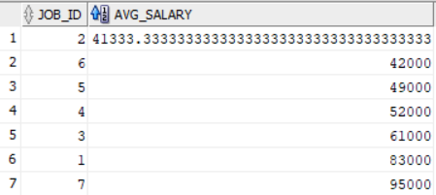GROUP BY job_id;

**--15.Roles with more than 2employees**

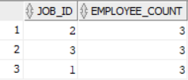SELECT job_id, COUNT(*) AS employee_count

FROM staff

GROUP BY job_id

HAVING COUNT(*) > 2;

**--16. Format the hire date of employees as 'Month Day, Year'**

SELECT first_name, last_name,

TO_CHAR(hire_date, 'Month DD, YYYY')

AS formatted_hire_date

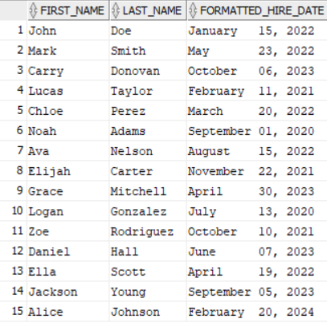FROM staff;

**--17. Extract the year from the patient's admission date**

SELECT patient_first_name, patient_last_name,

EXTRACT(YEAR FROM admission_date) AS admission_year

FROM patients;

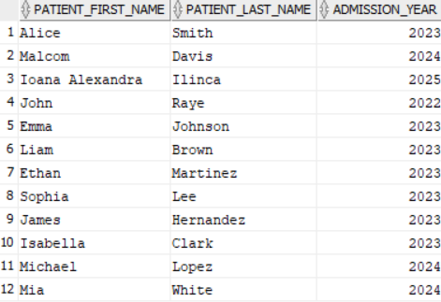

**--18. Get the first 3 characters of the patient's last name**

SELECT patient_first_name,

SUBSTR(patient_last_name, 1, 3)

AS short_last_name

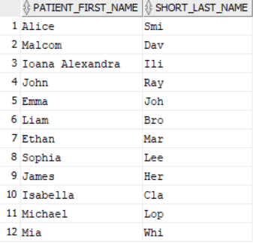FROM patients;

**--19.Employees hired within the last 2 years**

SELECT * FROM staff

WHERE hire_date >= SYSDATE - 730;

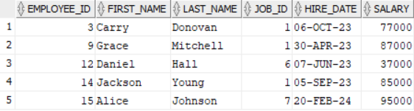

**-- 20.Display job title with custom labels based on salary**

SELECT first_name, last_name,

DECODE(salary, 50000, 'Mid-Level', 70000, 'Senior-Level', 'Junior-Level')

AS job_level

FROM staff;

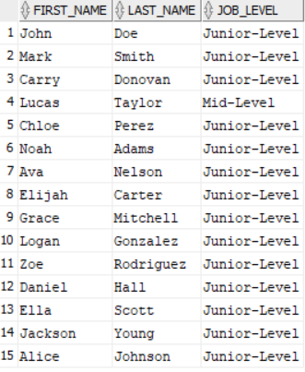

**--21. Display patient's status based on discharge date**

SELECT patient_first_name, patient_last_name,

CASE

WHEN discharge_date IS NULL THEN 'Currently Admitted'

ELSE 'Discharged'

END AS patient_status

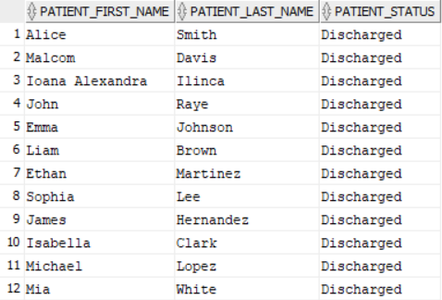FROM patients;

**-- 22.Show 'Assigned' if the supply is assigned to any patient**

SELECT supply_id,

CASE

WHEN quantity_used IS NULL THEN 'Not Assigned'

ELSE 'Assigned'

END AS assignment_status

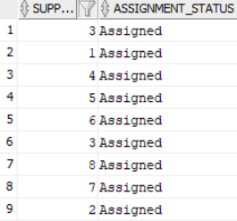FROM supplies_assigned;

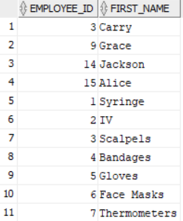**--23.Unites employees with salaries over 70000 with**

**the supplies that have a stock over 100**

SELECT employee_id, first_name

FROM staff

WHERE salary > 70000

UNION

SELECT supply_id, supply_name

FROM supplies

WHERE quantity_in_stock > 100;

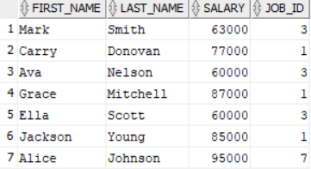**--24.Employees who are earning a salary greater**

**than the average salary for their job role**

SELECT first_name, last_name, salary, job_id

FROM staff

WHERE salary > (SELECT AVG(salary)

FROM staff WHERE job_id = staff.job_id);

**--25.An index on the patient's last name to improve query performance**

CREATE INDEX idx_patient_last_name ON patients(patient_last_name);



**--26.A synonym for the patients table**

CREATE SYNONYM patient_info FOR patients;



**--27.A sequence for generating unique request IDs**

CREATE SEQUENCE request_id_seq START WITH 1000 INCREMENT BY 1;



**--28.A view for employees and their role information**

CREATE VIEW employee_roles AS

SELECT s.first_name, s.last_name, r.job_title, r.min_salary, r.max_salary

FROM staff s

JOIN roles r ON s.job_id = r.job_id ;

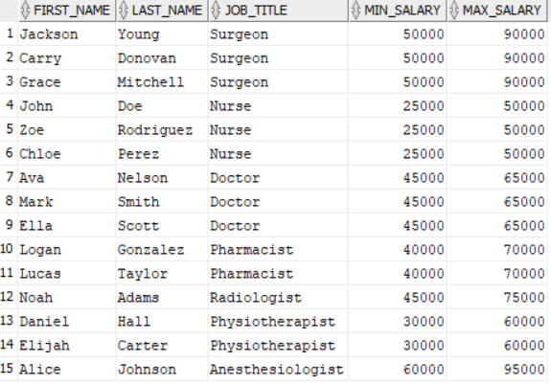

**-- 29.Retrieve patient names and discharge dates, displaying 'Still Admitted' if the discharge date is NULL**

SELECT patient_first_name,

patient_last_name,

NVL(TO_CHAR(discharge_date, 'YYYY-MM-DD'), 'Still Admitted')

AS discharge_status

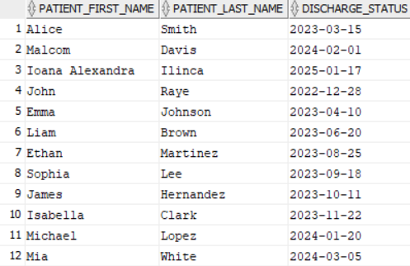FROM patients;

**-- 30.The hierarchy of employees in the hospital by salary**

WITH ranked_employees AS (

SELECT employee_id, first_name, last_name, salary,

ROW_NUMBER() OVER (ORDER BY salary DESC) AS rank

FROM staff

)

SELECT employee_id, first_name, last_name, salary, LEVEL

FROM ranked_employees

START WITH rank = 1

CONNECT BY PRIOR rank = rank - 1

ORDER BY LEVEL;

